Graduate Seminar in Ecology
EEOB 8896.04 (1 credit hour)
Phenotypic plasticity, adaptations, and climate change

class #: 35049
Instructor: Dr. Libby Marschall
marschall.2@osu.edu
614-292-8767
Meeting times: Tuesdays, 1:50-3:40pm-- alternating weeks

This seminar will be focused on recent research across taxa and systems on the interaction between rapid environmental change (specifically, climate change), phenotypic plasticity, and adaptation.
We will meet on alternating weeks, resulting in seven 2-hour meetings over the course of the semester.
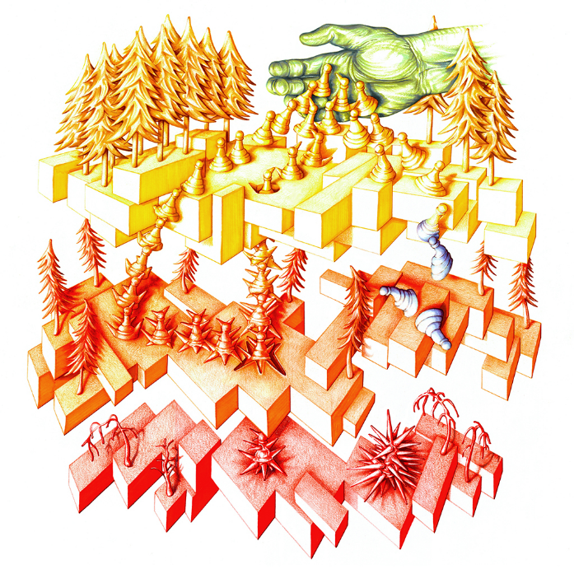

https://royalsocietypublishing.org/toc/rstb/374/1768

Art by Damien Veal. The hand of anthropogenic-driven climate change pours organisms through an environmental sieve. Many are poured out, but only a few survive to the final layer. Those who are able to adapt can do so in one of two ways - they can either evolve the phenotype required to make it through to the next layer; or, by expressing adaptive plasticity, they may buy themselves some time and an alternative route onwards to the next layer. But for some, like those on the right of the image, maladaptive plasticity can result in a dead-end. The organisms we observe at the bottom layer may have arrived there either via evolution or adaptive plasticity - we can’t tell which - science has yet to determine which process will be more important and whether they will work in tandem or in opposition.

