EEOB 5194
Autumn 2021
Interdisciplinary Team Science
The Interdisciplinary Team of Instructors:
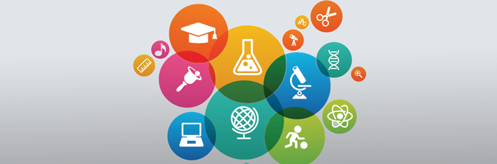
Alison Bennett (bennett.1242@osu.edu), Charlene Brenner, Jeff Agnoli, Marcela Hernandez, Liz Kirby, Mark Moritz, Risa Pesapane, Zoe Plakias, Courtney Price, Virginia Rich, Cathy Ryan, Leslie Shoaf, Leo Taylor, Samuel White
Credit Hours: 2
Meeting times: T/Th 10:20-11:15, Baker Systems 130

Funding agencies worldwide, including the NSF, are placing greater emphasis on interdisciplinary research. For example, the NSF has identified “Growing Convergence Research” as one of its 10 Big Ideas. True convergence research requires the development of interdisciplinary scientific teams (groups of 2 or more working collaboratively to solve a problem). However, graduate students are often siloed within programs, and not necessarily trained to engage with others outside their field. This course aims to teach students the necessary skills to lead or participate in scientific or interdisciplinary teams.
The lectures, activities and assignments in this course are designed to provide students with a handbook for building and maintaining a scientific team by the end of the course.

