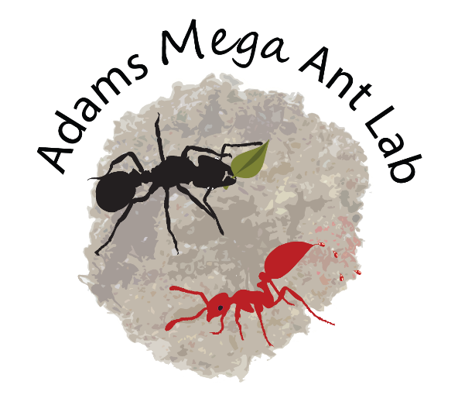
I am looking for lab members with interest in the evolution, ecology, and behavior of symbiotic interactions in social insects. I believe that the most successful research projects are those in which there is an alignment of my interests and my student’s, but I also welcome applicants with ideas for projects that are more independent. Most importantly, students should feel a strong sense of ownership of their thesis projects and the intellectual and physical work involved in making them successful.
Students in my lab are supported through a combination of internal and external fellowships, personal grants and NSF funding. They are expected to actively seek funding and the scope of their thesis research may be influenced by their success. I currently hold two NSF grants that could potentially support thesis projects:
- Illumination of behavior leading to host exploitation by a context-dependent mutualist [link]
- Integrative Systematics: Taxonomy and Evolution of Megalomyrmex Ants and Their Venom [link]

I aim to provide students with a professional environment where they can thrive as researchers and tools and advice to support personal success. Applicants should have interest and experience in evolution, ecology, microbiology, chemical ecology, and/or behavioral ecology and be familiar with my research program (see https://megalomyrmex.osu.edu/). If you would like to join my research group, please send me a single pdf including 1) a letter of motivation (your interests, past experience, and why you want to work with me), 2) a CV, 3) an unofficial transcript, and 4) the names and addresses of two references. After we meet I may encourage you to apply to our program (link; fee waivers link).
**Transcripts are requested at this stage to determine OSU fellowship eligibility. I strongly believe that opportunities and access are not equally distributed and that this can be reflected in grades. Please do not let my request dissuade you from inquiring.
I am committed to diversifying STEM through the training of students and public outreach. Please read my diversity statement and learn about my lab at https://megalomyrmex.osu.edu/ .
All students who are accepted into the EEOB Graduate Program receive support for 3 (M.S.) or > 5 (Ph.D.) years by becoming a teaching or research assistant. No loans are necessary to complete a degree. More details on the EEOB Graduate Program can be obtained at our departmental website (https://eeob.osu.edu/grad/graduate-program). Corey Ash is our graduate student coordinator and can answer questions about graduate admissions. The EEOB application materials are due November 15th for programs to begin the following Autumn. By the time of admission, applicants must have earned a B.Sc. or B.A. from an accredited institution with a major in one of the life sciences.

