8896.19

**Coming to a classroom near you Spring 2023!!!**

Hopkins/Bennett

**Applied multivariate statistics for research**

Meets two days a week

Time TBD based on student schedules

Aronoff 422

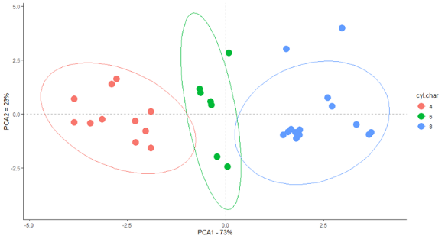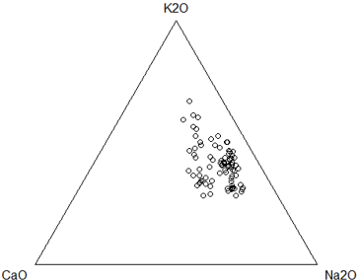

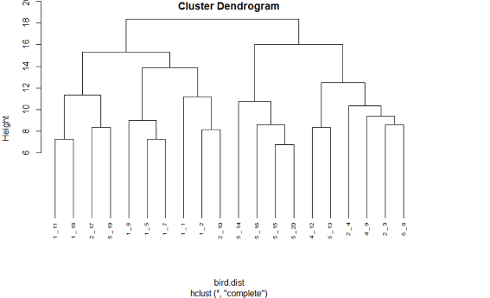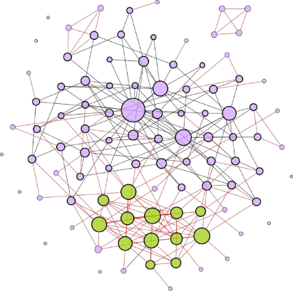

Interested in using multivariate statistical methods in your research, but aren’t fan of heavy math and statistics? This seminar will both discuss and provide practical instruction in how to appropriately use methods like ordination, PERMANOVA, factor analysis, structural equation modeling, network modeling, and CoDA methods in your research. We will meet two days a week with Day 1 focusing on lecture and discussion of the method(s), and Day 2 focusing on how to use the method in R. This course will not be HW intensive and will instead rely on in-class participation and a small final project for evaluation. **Email Hopkins.982@osu.edu with any questions about the course!**