Hiring Research Assistants for Summer 2017!
Goodell Lab
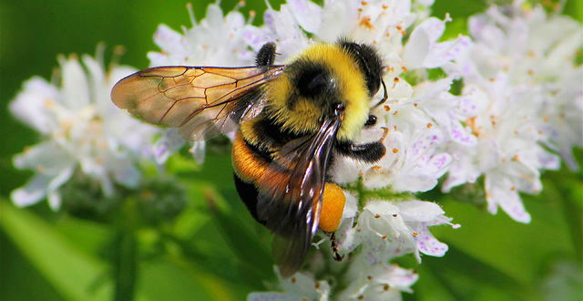
We will be conducting a state-wide survey of bumble bees to document their distributions and habitat requirements. Special efforts will focus on locating populations of the endangered Rusty Patched Bumble Bee. The position requires time in the field and in the lab and is paid. Approximate number of hours per week is 30h. Responsible students who have a flexible schedule and can work as part of a team are sought. Applicants with an interest in entomology, ecology, evolution, natural resources, conservation, and environmental studies encouraged to apply. Ability to travel for surveys is required. This is not an ideal position for someone who is allergic to bee stings because of a slight risk of stings.
Student workers could work out of Columbus or Newark.
Send a statement of interest, cv (or resume) and unofficial transcript ASAP, but by May 15 to:
Dr. Karen Goodell
Department of Evolution, Ecology and Organismal Biology
Email: goodell.18@osu.edu

